Navigate to https://uchicagomedicine.org/oraclecloud

Use the User ID / Password section to log in, not the Company Single Sign-On. To use this section for the first time, follow the below instructions. A pre-requisite for this is a personal email address must be recorded on the person’s HR record in Oracle Cloud.
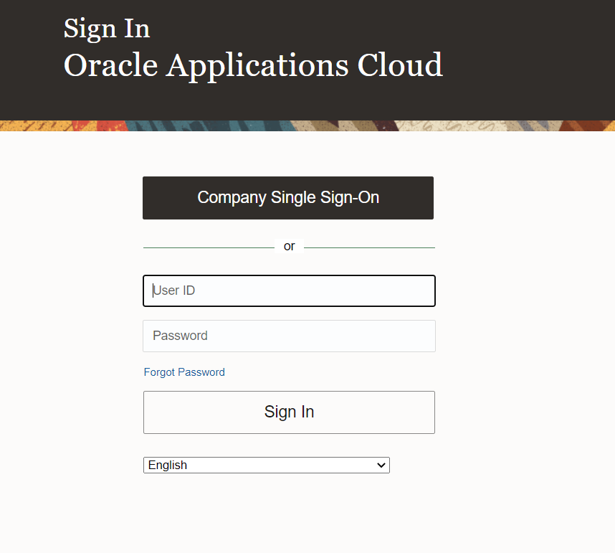
- Click “Forgot Password”
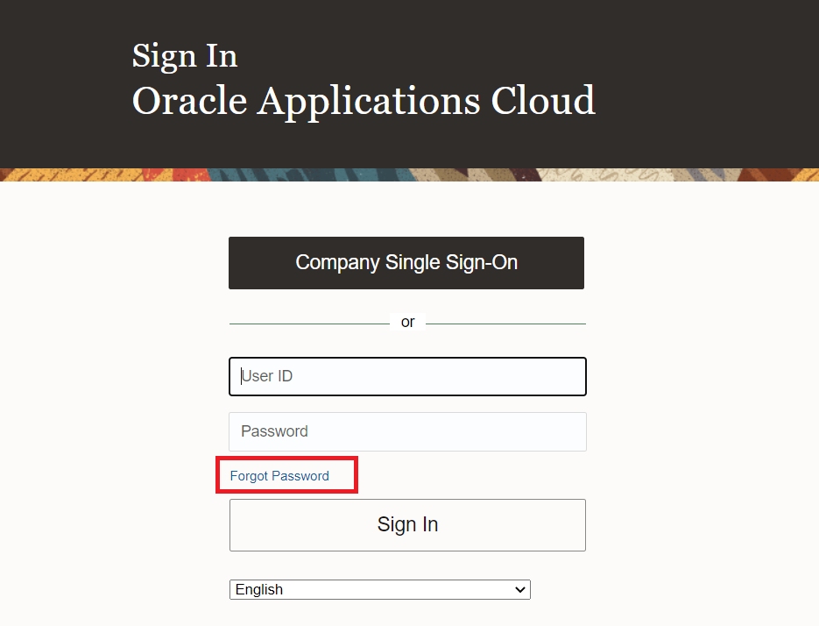

- Your username is your Chicago ID (not your UCMED ID or UCHAD ID). If you don’t remember your Chicago ID, either call the Service Desk and ask, or, click the ‘Forgot user name’, enter your prior UCM email address, and click submit. An email should be sent to your personal email address with your username. If an email does not arrive, attempt this step again, using a different corporate email address domain (@uchospitals.edu / @uchicagomedicine.org). If an email still doesn’t arrive, contact the Service Desk and ask for your Chicago ID.
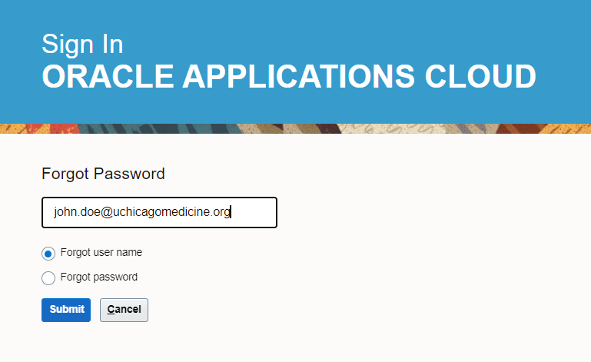
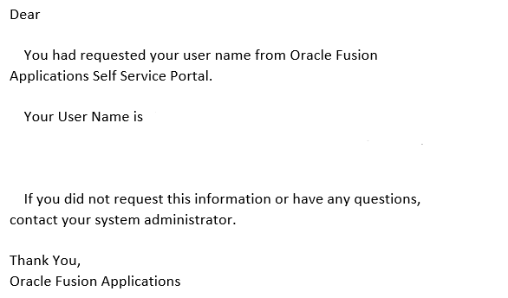

- To retrieve your password, put in your username (Chicago ID), select forgot password, and click submit. An email should be sent to your personal email address allowing you to reset your password. If an email isn’t sent to your personal email, contact the Service Desk for further assistance.

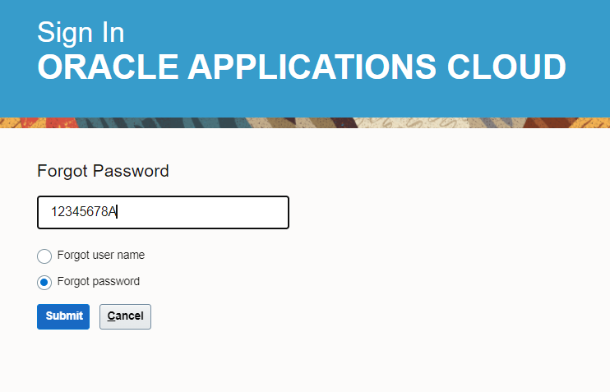
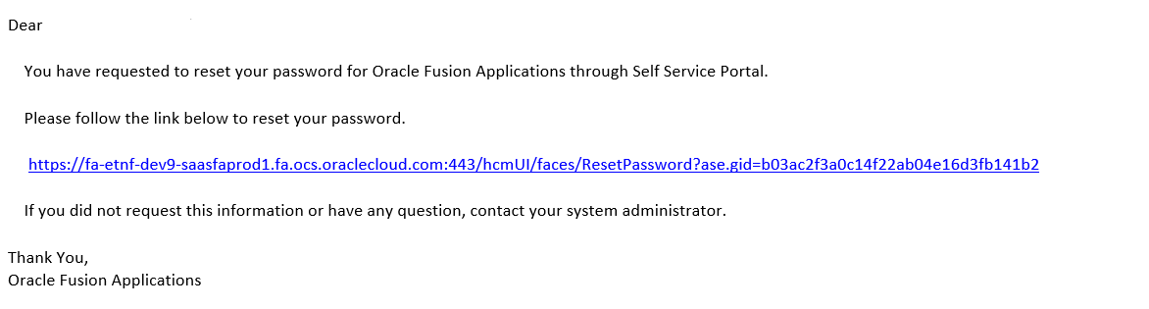

- Log in with your username and new password.
